MetaBase

About:
- Metabase is an open-source business intelligence platform that lets you:
  - Ask questions about your data
Key capabilities:
- Display charts and dashboards
- Create interactive filter widgets
- Allow data exports
- Enable self-service analytics via query builder
- Embed visualizations in your applications
Metabase can be used to:
- Create and share dashboards
- Build interactive visualizations
- Embed analytics in your applications
- Set up multi-tenant data access

Installation:
- Open Source: https://www.metabase.com/start/oss/
  - Docker Image (requires Docker)
  - JAR file (requires Java 21 or higher available on your system)
- Enterprise Edition: Activating your Metabase commercial license

Metabase Features and Configuration Notes:
- Static embedding:
  - To access static embedding: Go to Settings > Admin settings > Embedding > Toggle the Enable embedding option
    - For individual questions or dashboards: Navigate to questions / dashboard > Click the sharing icon > Select Embed > Choose Static embedding > Click Publish
    - Generate embedding URL using secret key to sign JWTs
    - Secret key can be regenerated: Settings > Admin settings > Embedding > Static embedding > Manage > Regenerate secret key > Regenerate key
  - Drill down option is not available
  - Metabase Logo can’t be hidden
  - Only dashboard filter will work
  - Individual question filter will not work
  - Token required and the time limit can be minimum 1 seconds
  - Font can’t be changed
  - Disabling downloads is only available on Pro and Enterprise plans
  - Auto-refreshing is only available for dashboards, not questions while embedding
    - Auto-refresh will not clear the dashboard filter
  - Night theme available
- Automatic send mail feature for questions & Dashboards
  - To set up email: Admin Panel > Email settings > Configure required SMTP settings
  - We can setup multiple schedulers per Dashboard or a question
  - Frequency:
    - Hourly
    - Daily (every hour)
    - Weekly (every hour)
    - Monthly (first, last & midpoint)
  - No limit for sending mail
- Alerts:
  - It let user to monitor questions and get notified when specific conditions are met.
  - Type of alert as follows:
    - Results alerts: Notify when a question returns any results
    - Goal line alerts: Notify when a time series crosses a goal line
    - Progress bar alerts: Notify when a progress bar reaches/goes below its goal
  - Alerts can be sent via Email, Slack & Webhooks
  - To create alert: Save questions > Click sharing icon > Create alert
- User management:
  - To access User management: Click the gear icon > Admin settings > People
  - Only user with Metabase access can have create the dashboard / question
  - Admin user can invite users to access Metabase
    - Metabase Admin > People > Invite someone > First, last name, email & group
      - Mail will be sent with link to generate password against email id
    - Admin user can edit, reset password & deactivate user
  - Users can be assigned to a group to control the access limit
    - Metabase Admin > Permissions > Data
      - access of the DB, per table of the DB & creating question
    - Metabase Admin > Permissions > Collections (collection will be based on the DB)
  - Each group can either View / Full Access / No Access
  - No limit for users
- Public links:
  - Links show static (view-only) results
  - It can be disabled at any time
  - Admin user can create a public link for question / dashboard.
    - User can share the webpage or allow user to download csv / excel / json file using the link
- To allow specific domains: Metabase Admin > General > Allowed domains for iframes in dashboards
- Tables can display 2000 rows & pivot table can display 10,000 rows only
- Only charts can be exported as png format all others can export data as csv, excel & json
- All users can able to see the data in trash – it’s better to delete from trash if the data is confidential.
- Combine columns option available with separator (Eg: tag & tag options)
- Allows to add title & text on Dashboard (for description purpose)
- By default, rounds the value to 2 DP.
- On export to csv / excel, 1 million rows can be exported.

Metabase Environment Variables
- Link: https://www.metabase.com/docs/latest/configuring-metabase/environment-variables

🛠️ Server Configuration
- MB_JETTY_PORT - Port on which Metabase's web server listens. (Default: 3000)
- MB_JETTY_HOST - Host interface Metabase binds to (e.g., 0.0.0.0). (Default: localhost)
- MB_JETTY_SSL - Enable HTTPS (true/false). (Default: false)
- MB_JETTY_SSL_PORT - Port for HTTPS connections. (Default: 8443)
- MB_JETTY_SSL_KEYSTORE - Path to Java KeyStore (.jks) file.
- MB_JETTY_SSL_KEYSTORE_PASSWORD - Password for the Java KeyStore.
- MB_JETTY_MAXTHREADS - Max threads for handling requests. (Default: 50)
- MB_JETTY_MAXIDLETIME - Max idle time in milliseconds. (Default: 200000)
- MB_JETTY_JOIN - Whether server thread blocks until stop (true/false). (Default: true)

🧠 Application Behavior
- MB_CHECK_FOR_UPDATES - Enable automatic update checks (true/false). (Default: true)
- MB_EMAIL_FROM_ADDRESS - Sender email in outgoing emails. (Default: notifications@metabase.com)
- MB_EMAIL_FROM_NAME - Sender name in outgoing emails.
- MB_PASSWORD_COMPLEXITY - Password complexity (normal/strong). (Default: normal)
- MB_PASSWORD_LENGTH - Minimum password length. (Default: 10)
- MB_CUSTOM_HOMEPAGE - Enable custom dashboard as homepage (true/false). (Default: false)
- MB_CUSTOM_HOMEPAGE_DASHBOARD - ID of the dashboard to use as custom homepage.

📊 Data Handling
- MB_DB_TYPE - Application DB type (h2, postgres, mysql, etc.). (Default: h2)
- MB_DB_HOST - Hostname of application DB. (Default: localhost)
- MB_DB_PORT - Port of application DB. (Default: 5432 for Postgres)
- MB_DB_NAME - Name of application DB. (Default: metabase)
- MB_DB_USER - DB username.
- MB_DB_PASS - DB password.
- MB_DB_CONNECTION_TIMEOUT_MS - DB connection timeout in ms. (Default: 10000)
- MB_DB_QUERY_TIMEOUT_MINUTES - Query timeout in minutes. (Default: 20)

📈 Analytics and Monitoring
- MB_PROMETHEUS_SERVER_PORT - Port for Prometheus metrics. (Default: 9191)
- MB_UNAGGREGATED_QUERY_ROW_LIMIT - Max rows for unaggregated queries.
- MB_ATTACHMENT_TABLE_ROW_LIMIT - Max rows in alert/subscription tables. (Default: 20)
- MB_ATTACHMENT_ROW_LIMIT - Max number of rows included in a subscription/alert attachment. (Default: 1000)
- MB_DOWNLOAD_ROW_LIMIT - Max number of rows a user can download from a result. (Default: 100000)

🧪 AI and Experimental Features
- MB_EE_AI_FEATURES_ENABLED - Enable AI features (true/false). (Default: false)
- MB_EE_OPENAI_API_KEY - OpenAI API key.
- MB_EE_OPENAI_MODEL - OpenAI model to use (e.g., gpt-4). (Default: gpt-4-turbo-preview)

Link
Sno | Link with Desc
 | Metabase docs
 | Static embedding
 | Conditional formatting with two factors
Field filters: smart filters for SQL questions | Metabase tutorial
Field filters for SQL questions
SQL parameters and filters | Metabase tutorial
How to set up dashboard filters for SQL queries | Metabase tutorial
How to use dashboard filters | Getting started with Metabase
 | This database doesn’t have any tables. - MySQL
 | Metabase download based on version
 | Pricing
 | Metabase Forum
 | Alerts
 | Available docs versions
 | List of expressions
 | Custom expressions
 | Metabase documentation
 | Actions on dashboards
 | Metabase Image
Is it possible to create a filter linked to another in embedded dashboards?

Refer mail subject: [Metabase Discussion] Summary
 | Environment variables
 | Save questions to dashboards, dynamic iframe cards, preemptive caching, and more

ETL Process
API File for daily cron jobs: C:\wamp\www\elastik-client-api\Reports\Warehouse
API script file location: C:\wamp\www\elastik\extras\api\warehouse\script
Cron job logs: Control panel > Reports > Client Cron Logs
BI report types:
- Metabase reports embedded on analytics
- Custom reports
  - API file: C:\wamp\www\elastik-client-api\Analytics\Reports
  - Report module: C:\wamp\www\elastik-analytics\modules\reports
Adding report on analytics: Control Panel > Client Mgmt. > Clients > Anime > Products (Subpanel) > BUSINESS INTELLIGENCE > BI Reports > Create / Edit
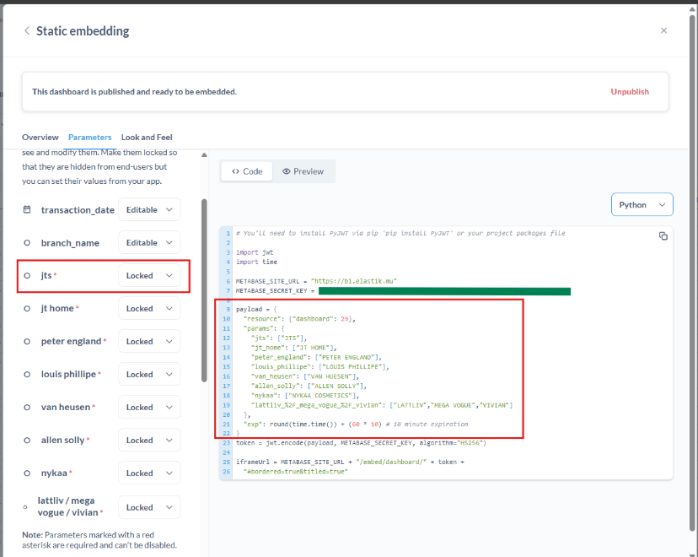

Metabase (Community version v0.55.6):
  - Control Panel
    - Settings > Admin Settings
      - Settings > Email
      - Database > Add database (Model persistence)
      - People > Invite user / Group access
      - Permissions > Group / Collections
      - Performance > Model Persistence > no change
      - Tools > Model Caching Log
      - Trouble shooting > Logs
  - Client Side
    - Collections
    - Questions
    - SQL Query
    - Dashboard
Pending task:
- AnalyticsFunctions:: invokeGetWarehouseDbConnection
  - Above should be moved same like C:\wamp\www\elastik-client-api\includes\dbClient.php
    - Need to create C:\wamp\www\elastik-client-api\includes\dbClientWarehouse.php

